Custom Rosaries Order Form
Example 1 Italian Rosary
Short Chain(5 Beads) Red x 1, White x 1, Green x 1, White x 1, Red x 1  Decade 1 (10 Beads) Red x 4, White x 2, Green x 4  Decade 2 (10 Beads) Red x 4, White x 2, Green x 4  Decade 3 (10 Beads) Red x 4, White x 2, Green x 4  Decade 4 (10 Beads) Red x 4, White x 2, Green x 4  Decade 5 (10 Beads) Red x 4, White x 2, Green x 4  Our Father/Glory Be White | 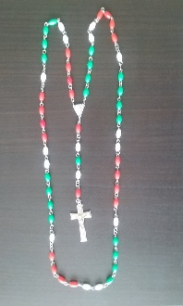
Example 2 Mother Theresa Rosary
Short Chain(5 Beads) Red x 1, Black x 1, Green x 1, Yellow x 1, Dark  Blue x 1  Decade 1 (10 Beads) Red  Decade 2 (10 Beads) Black  Decade 3 (10 Beads) Green  Decade 4 (10 Beads) Yellow  Decade 5 (10 Beads) Dark Blue  Our Father/Glory Be White | 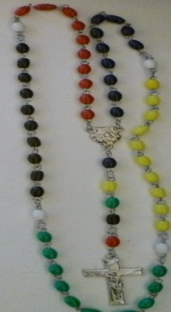
Your Rosary
Short Chain(5 Beads) __________________________________________________________

_______________________________________________________________________________

Decade 1 (10 Beads) __________________________________________________________

_______________________________________________________________________________

Decade 2 (10 Beads) __________________________________________________________

_______________________________________________________________________________

Decade 3 (10 Beads) __________________________________________________________

_______________________________________________________________________________

Decade 4 (10 Beads) __________________________________________________________

_______________________________________________________________________________

Decade 5 (10 Beads) __________________________________________________________

_______________________________________________________________________________

Our Father/Glory Be (4 Beads) __________________________________________________________

